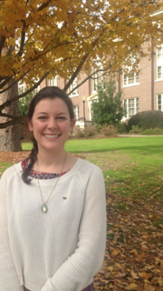
If a prospective student were to walk on Spring Hill’s campus, chances are he or she would see Elizabeth Briggs ’16. Since entering Spring Hill, Briggs has become a leader and role model for the student body. The English major and Sociology minor from Lafayette, La. has kept herself busy, being a LEAP Freshmen mentor, a tele-recruiter in the Spring Hill College Office of Admissions, an Alumni Ambassador, the president of Phi Mu Fraternity, and a participant in the Spring Hill Italy Program. During her time abroad, Briggs’ love for social justice was reaffirmed; she now plans to build upon her social justice background from Spring Hill with hopes of serving in the Jesuit Volunteer Corps for a year before attending law school. Briggs states that Spring Hill was always meant to be home, and when she stepped foot on the campus she knew exactly where she was supposed to be. She has continued to embody everything Spring Hill stands for, and is always thankful for those who helped her get to her current state. “I would love to say thank you so much to those who donated. Thank you for believing in me and the mission of Spring Hill. It means more than the world to me, and I promise I won’t let you down!”
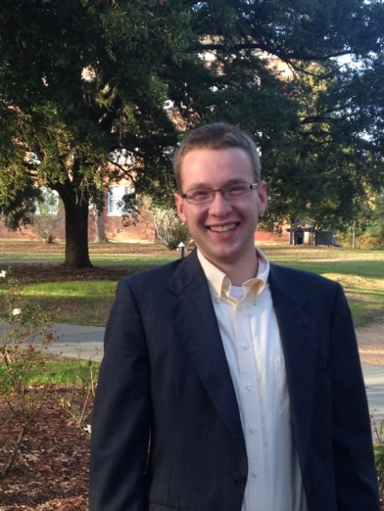
Patrick Lameka ’16 originally chose Spring Hill for the beautiful campus and small school atmosphere, and cites the wonderful people as the reasons he has continued to stay. Lameka came from Chicago, Ill. and is a Business Management and Marketing major and Theology minor. He is a member of Lamda Chi Alpha fraternity, the Attorney General of the Student Government Association, a Springhillian tour guide and student ambassador, and a member of the cross country and track and field teams. Lameka is always grateful to the donors who have helped him along the way. “If I were to meet a donor, I would tell him or her thank you because they have made it possible for me to go to such a wonderful institution.” Lameka hopes to further his education one day and attend graduate school, but will always be thankful for his time at Spring Hill. “I love that Spring Hill focuses on academic, but gives the student the incredible ability to get involved and be active in the community.”
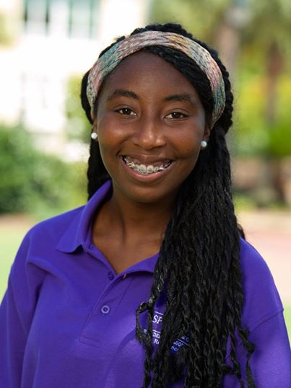
Originally, Jasmine Littles ’17 chose Spring Hill because of the beautiful campus and location. But, according to Littles, the people and wonderful community on the Hill are what keep her thankful every day. Littles came to Spring Hill from Zachary, La. and has become a prominent figure on campus. She is a Resident Advisor for the freshmen Cultural Immersion Pod, a Springhillian tour guide and ambassador and a member of Phi Mu Fraternity. Littles is a Psychology major on an Occupational Therapy track with hopes of attending OT school and eventually a doctoral program. As involved of a student as she is, she is continually grateful to those who made Spring Hill an option for her. “I want to say thank you to all those who keep Spring Hill College such a wonderful place. I am truly blessed.”
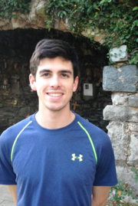
For Scout Kirkikis ’15, Spring Hill College has been a family affair. Having his mother and three older brothers attend Spring Hill, Scout knew it had to be a special place. And once the Kenner, La. native enrolled in Spring Hill in 2011, it did not disappoint. Over the past four years, Kirkikis has become an integral part of the Spring Hill community. He is a part of the American Student Medical Association (AMSA), the Spring Hill Oceanic Research and Exploration Society (SHORES) and currently serves as the Senior Class President on the Student Government Association. He is also a dedicated student as a Biology major on the Pre-Medicine track. Last year, Kirkikis participated in the Spring Hill Pre-Medicine Internship Program, where he was able to shadow physicians in different specialties for a total of 40 hours over the course of the year. He states this experience was extremely valuable and solidified his hopeful plans of attending medical school after graduation. Kirkikis is continually thankful for those donors at Spring Hill who have made the experience such an important part of his and his family’s lives. “I really appreciate your support to this fantastic school. People like you are the ones who make Spring Hill so enjoyable!”
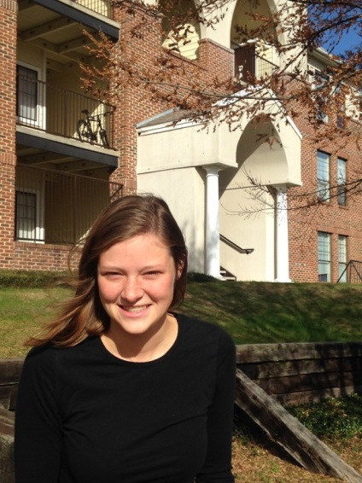
Victoria Fasi ’15 was first introduced to Spring Hill from her desire to move down South. Fasi, who is from Brookfield, Wis., thought Mobile, Ala. stood out from the rest of cities she looked at. Once she took her tour of Spring Hill, it was a done deal. Ever since that day, Fasi has become highly involved both socially and academically. She is a member of Phi Mu Fraternity, president of the Spring Hill Oceanic Research and Exploration Society (SHORES) and a tele-recruiter for the Spring Hill College Office of Admissions. Over the past four summers, Fasi has also had the opportunity to work in two different law firms in Milwaukee, Wis. In May 2015, she will be graduating from Spring Hill with a Bachelor of Science in International Studies with hopes of attending law school. While her time may be concluding at Spring Hill, Fasi reminisces on her time with great joy and a plethora of gratitude for those who made it possible. “Thank you for everyone who donated to Spring Hill. I would not be here if it was not for the scholarship opportunities and I am forever grateful.”

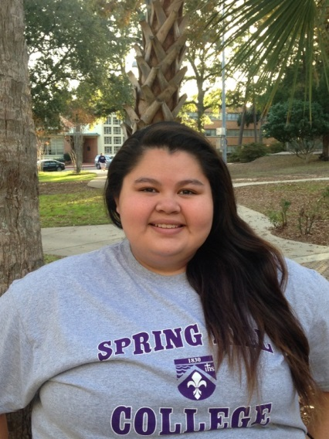
When Astrid Torres ’15 first toured Spring Hill, she was no stranger. The double major in Political Science and Hispanic Studies and minor in International Studies first heard about Spring Hill through her sister, Ingrid Torres ’13. “I ever thought my sister and I would attend the same institution after high school, but once I visited Spring Hill I recognized how special this place was, and why my sister came here,” says Torres. The Dallas, Texas native has given Spring Hill her all, serving on the Student Government Association and Political Science and International Studies Club all four years, and being a member of Delta Gamma Sorority. She one day hopes of attending law school to be a criminal defense attorney or work for the Department of Homeland Security. Torres has always been thankful for those who made Spring Hill possible for her and her sister. “I knew Spring Hill College would be a place where I would make lasting memories and be challenged to be the best person I could be. Thank you so much for making this experience happen for me, your support has allowed me to be part of such a wonderful community.”

