Community Summer Jobs Program 2013 Dauphin Island Sea Lab Interns
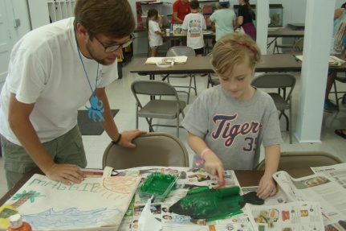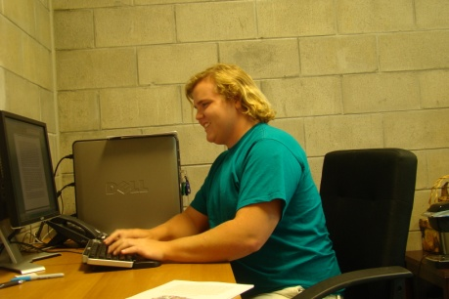
For a number of years Dauphin Island Sea Lab (DISL) has been a part of the ExxonMobil Community Summer Jobs Program, and this year was no exception. The program allowed funding for three internships at DISL, who selected Alison Zehnle, Jonathan Watts, and Andy Cuff as the summer interns. Each intern had a different area of focus and got to see the variety of work taking place at DISL. Even though each intern worked in a different area, each individual was thankful for the experience provided by DISL and ExxonMobil.
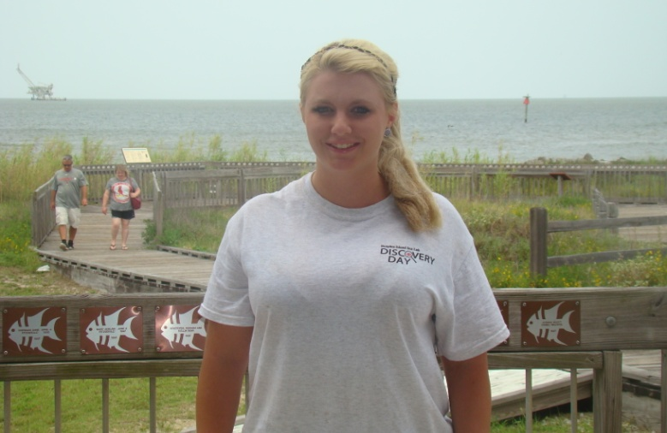
From Quincy, Ill., Alison Zehnle is a rising junior at Gadsden State. Alison is an Aquatic Biology major and was the Aquarist Intern at DISL this summer. Alison spent the majority of her time learning the operations of the Estuarium, the public aquarium at DISL. She assisted in the daily upkeep of exhibits, monitored the health of the animals, and occasionally worked with the general public. Alison was the first intern to work with the Rays of the Bay Touch Tank Exhibit, after it was installed in March of this year. This new interactive exhibit proved to be enjoyable for Alison, who assisted with catching each stingray and clipping their stingers. “I’ve only had experience with freshwater species, so all the salt water exhibits were all new to me. I gained significant experience with these exhibits and am very happy that I got to expand my horizons at DISL,” said Alison. Through all her hard work, Alison left DISL with new extensive knowledge of salt water aquariums and exhibits, and is thankful for the opportunity provided by ExxonMobil.
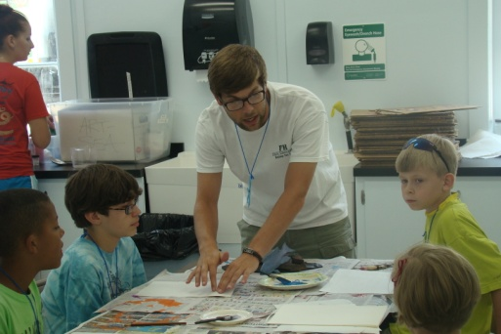
Jonathan Watts is a rising senior at Troy University and originally from Toney, Ala. Jonathan is an Environmental Science major, and was one of the Discovery Hall Program interns for the summer. The Discovery Hall Programs normally has a few interns, but Jonathan was the only one sponsored by ExxonMobil. During the summer, Jonathan assisted and helped run the camps and teacher workshops for the Discovery Hall Programs. There are many different programs for students during the summer, and range from ages 5-18. Although Jonathan contributed to all of them, his longest project was the Marine Science Course. The program is a 4-week residential program for high school students and Jonathon spent most of his time helping the counselors. Because of this, Jonathan had to familiarize himself with the Gulf Coast’s habitats quickly as he helped teach the students about marine environments and wildlife. He also took the high school students to the New Orleans Aquarium and to Panama City, Fla., for snorkeling in the sea grass beds. “It was definetly challenging in the beginning. I had to learn all about marine life that was unfamiliar to me, but I was happy to do it. Being able to work with these kids and teachers was truly wonderful and exciting to see their interest in the environment,” said Jonathan. Jonathan was appreciative to ExxonMobil and was pleased with the experience DISL provided him with.
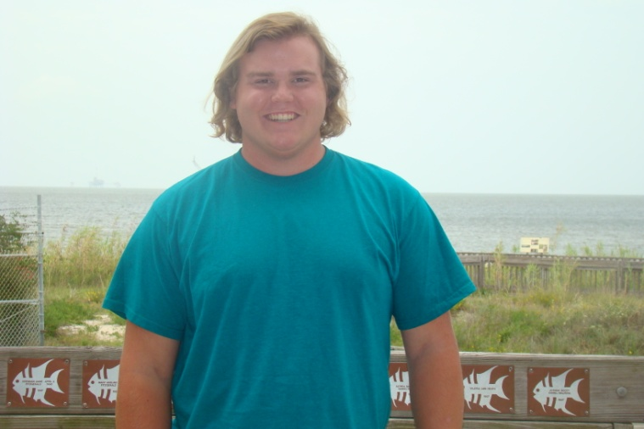
Andy Cuff is from Overland Park, Kan., and a rising junior at Spring Hill College. Andy is a Public Relations and Advertising major, and an International Studies minor at Spring Hill. At DISL, Andy was the Public Relations Intern. His main focus was writing press releases about each student and teacher attending all of the Discovery Hall Programs. Over the course of the summer, Andy wrote over 130 press releases that were sent to over 80 newspapers around the country. During the programs duration, Andy also kept himself busy taking pictures of all the programs to keep in stock for DISL. When programs were not in action Andy contributed stories to DISL’s monthly electronic newsletter, the Skimmer. At the conclusion of the summer, Andy was very thankful for the experience. “When I took trips out on the R/V Alabama Discovery to take pictures I got to see some pretty amazing things. I really enjoyed taking those experiences and writing them down and sending them across the country for others to see. It was a great combination of writing and photography and I couldn’t be happier I was offered the position,” said Andy. Andy was grateful for ExxonMobil and DISL and was ecstatic to spend his summer on Dauphin Island.

