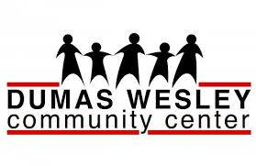
Backgrounder

FOR IMMEDIATE RELEASE FOR MORE INFORMATION, CONTACT:
September 15, 2014 Kate Carver
Executive Director
251-479-0649
kcarver@dumaswesley.org

Dumas Wesley Community Center’s New Event

Dumas Wesley Community Center will host its 1st Plane Pull fundraising event on Saturday Nov. 1, 2014 at 10 a.m. at the ST Aerospace facility located in Brookley Aeroplex. Teams with a maximum of 20 participants will attempt to pull a ST Aerospace aircraft 12 feet in a timed competition. Each team is required to raise a minimum of $1,000 in order to participate in the event. All proceeds with directly benefit Dumas Wesley Community Center.
Dumas Wesley was founded in 1903 and has been serving the Mobile area ever since. Located in Crichton, Dumas Wesley is a neighborhood based non-profit that serves the local community. With 69 percent of the clients served directly by Dumas Wesley Community Center classified as low-income and approximately 95 percent a minority, Dumas Wesley is constantly at work.
Dumas Wesley Community Center offers a wide variety of activities and services to benefit the needs of the community. After school programs, tutoring services, a food pantry and a transitional housing program are just some of the services provided by Dumas Wesley Community Center. Run entirely off of funds from government grants, contributions and special events, all donations are used to the fullest extent. Participants in the Plane Pull fundraising will directly assist Dumas Wesley in continually serving the community.
For more information on Dumas Wesley Community Center visit its website dumaswesley.org, and for more information on the upcoming Plane Pull event contact Kate Carver at karver@dumaswesley.org.
###

